Activity-1: This program illustrate the uses E notation Solution:
public class Activity31{
public static void main(String[] args){
double distance, mass;
distance = 1.495979E11;
mass = 1.989E30;
System.out.println("The sun is " + distance +" meters
away.");
System.out.println("The sun's mass is " + mass + "
kilograms.");
}
}
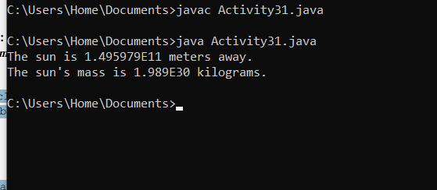
Activity-2: This program calculates hourly wages plus overtime. Solution:
public class Activity32{
public static void main(String[] args){
double regularWages;
double basePay = 25;
double regularHours = 40;
double overtimeWages;
double overtimePay = 37.5;
double overtimeHours = 10;
double totalWages;
regularWages = basePay * regularHours;
overtimeWages = overtimePay * overtimeHours;
totalWages = regularWages + overtimeWages;
System.out.println("Wages for this week are $" + totalWages);
}
}
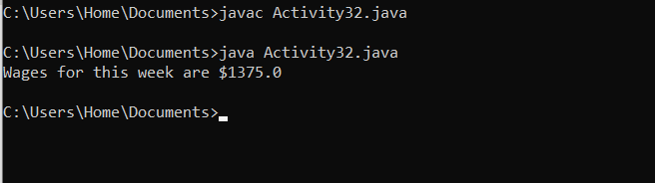
Activity-3: This program calculates the amount of pay that will be contributed to a retirement plan if 5%, 8%, or 10% of monthly pay is withheld.
Solution:
public class Activity33{
public static void main(String[] args){
double monthlyPay = 6000.0;
double contribution;
// Calculate and display a 5% contribution.
contribution = monthlyPay * 0.05;
System.out.println("5 percent is $" + contribution +" per month.");
// Calculate and display an 8% contribution.
contribution = monthlyPay * 0.08;
System.out.println("8 percent is $" + contribution + " per month.");
// Calculate and display a 10% contribution.
contribution = monthlyPay * 0.1;
System.out.println("10 percent is $" + contribution + " per
month.");
}
}
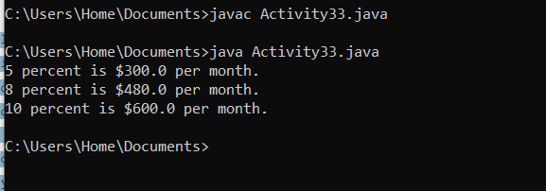
Activity-4: This program displays a variety of floating-point numbers in a column with their decimal points aligned.
Solution:
public class Activity34{
public static void main(String[] args){
// Declare a variety of double variables.
double num1 = 127.899;
double num2 = 3465.148;
double num3 = 3.776;
double num4 = 264.821;
double num5 = 88.081;
double num6 = 1799.999;
// Display each variable in a field of
// 8 spaces with 2 decimal places.
System.out.printf("%8.2f\n", num1);
System.out.printf("%8.2f\n", num2);
System.out.printf("%8.2f\n", num3);
System.out.printf("%8.2f\n", num4);
System.out.printf("%8.2f\n", num5);
System.out.printf("%8.2f\n", num6);
}
}
Activity-5: This program displays the sales tax with two digits after the decimal point
Solution:
import java.util.Scanner;
public class Activity35 {
public static void main(String[] args) {
Scanner input = new Scanner(System.in);
System.out.print("Enter purchase amount: ");
double purchaseAmount = input.nextDouble();
double tax = purchaseAmount * 0.06;
System.out.println("Sales tax is $" + (int)(tax * 100) /
100.0);
}
}
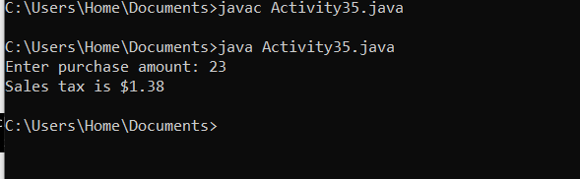
Lab Task 1
Suppose you want to develop a program that changes a given amount of money into smaller monetary units. The program lets the user enter an amount as a double value representing a total in dollars and cents, and outputs a report listing the monetary equivalent in the maximum number of dollars, quarters, dimes, nickels, and pennies, in this order, to result in the minimum number of coins Here are the steps in developing the program: 1. Prompt the user to enter the amount as a decimal number, such as 11.56. 2. Convert the amount (e.g., 11.56) into cents (1156). 3. Divide the cents by 100 to find the number of dollars. Obtain the remaining cents using the cents remainder 100. 4. Divide the remaining cents by 25 to find the number of quarters. Obtain the remaining cents using the remaining cents remainder 25. 5. Divide the remaining cents by 10 to find the number of dimes. Obtain the remaining cents using the remaining cents remainder 10. 6. Divide the remaining cents by 5 to find the number of nickels. Obtain the remaining cents using the remaining cents remainder 5. 7. The remaining cents are the pennies. 8. Display the result. You are required to implement the above steps 1-8 in JAVA language.
Solution

import java.util.Scanner;
public class CoinConverter{
public static void main(String[] args){
Scanner sc = new Scanner(System.in);
System.out.println("Enter the amount as decimal number (e.g, 11.56): ");
double amount = sc.nextDouble();
int totalCents = (int) Math.round(amount * 100);
int dollars = totalCents / 100;
int remainingCents = totalCents % 100;
int quarters = remainingCents / 25;
remainingCents %= 25;
int dimes = remainingCents / 10;
remainingCents %= 10;
int nickels = remainingCents / 5;
remainingCents %= 5;
int pennies = remainingCents;

System.out.println("Dollars: " + dollars);
System.out.println("Quarters: " + quarters);
System.out.println("Dimes: " + dimes);
System.out.println("Nickels: " + nickels);
System.out.println("Pennies: " + pennies);

sc.close();
}
}
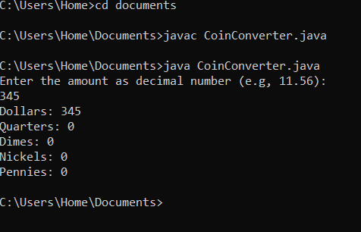

Lab Task 2
N students take K apples and distribute them among each other evenly. The remaining (the undivisible) part remains in the basket. How many apples will each single student get? How many apples will remain in the basket? The program reads the numbers N and K. It should print the two answers for the questions above.
import java .util.Scanner;
public class Lab3Task2{
public static void main(String[] args){
Scanner sc = new Scanner(System.in);
int N = sc.nextInt();
int K = sc.nextInt();
int Applesperstudent = K/N;
int remaining = K%N;
System.out.println("Each student get apples:" + Applesperstudent);
System.out.println("Apples left in basket:" + remaining);
}
}
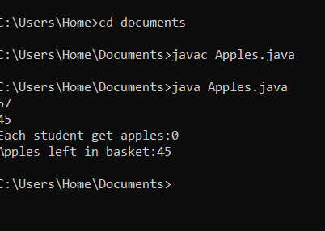
Lab Task 3
A school decided to replace the desks in three classrooms. Each desk sits two students. Given the number of students in each class, print the smallest possible number of desks that can be purchased. The program should read three integers: the number of students in each of the three classes, a, b and c respectively. Input: Output: 17 28 19 18 Lab Task 4 Given the integer N – the number of minutes that is passed since midnight - how many hours.
Solution
import java.util.Scanner;
public class DeskCalculator{
public static void main(String[] args){
Scanner sc = new Scanner(System.in);
int a = sc.nextInt();
int b = sc.nextInt();
int c = sc.nextInt();
int desks = (a+1)/2 + (b+1)/2 + (c+1)/2;
System.out.println("Minimum desks required:" + desks);
}
}
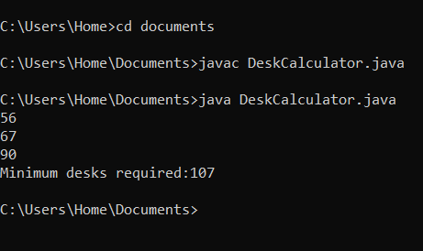
Task 4
Given the integer N – the number of minutes that is passed since midnight - how many hours and minutes are displayed on the 24h digital clock? The program should print two numbers: the number of hours (between 0 and 23) and the number of minutes (between 0 and 59). For example, if N = 150, then 150 minutes have passed since midnight - i.e. now is 2:30 am. So the program should print 2 30.
Solution
import java.util.Scanner;
public class Hours{
public static void main(String[] args){
Scanner sc = new Scanner(System.in);
int N = sc.nextInt();
int hours = (N/60)%24;
int minutes = N%60;
System.out.println(hours + " " + minutes);
}
}
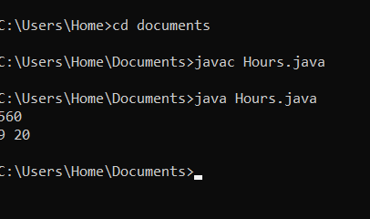

Lab Task 5
A milk carton can hold 3.78 liters of milk. Each morning, a dairy farm ships cartons of milk to a local grocery store. The cost of producing one liter of milk is $0.38, and the profit of each carton of milk is $0.27. Write a program that does the following: a. Prompts the user to enter the total amount of milk produced in the morning b. Outputs the number of milk cartons needed to hold milk (Round your answer to the nearest integer.) c. d. Outputs the cost of producing milk Outputs the profit for producing milk.
import java.util.Scanner;
public class MilkProduction{
public static void main(String[] args){
Scanner input = new Scanner (System.in);
double CARTON_CAPACITY = 3.78;
double COST_PER_LITRE = 0.38;
double PROFIT_PER_CARTON = 0.27;

System.out.println("Enter the total amount of milk produced in litres: ");
double totalMilkProduced = input.nextDouble();
long numberOfCartons = Math.round(totalMilkProduced / CARTON_CAPACITY);
System.out.println("Number of milk cartons needed: " + numberOfCartons);
double totalProductionCost = totalMilkProduced * COST_PER_LITRE;
System.out.printf("Cost of producing milk: $%.2f/n", totalProductionCost);
double totalProfit = numberOfCartons * PROFIT_PER_CARTON;
System.out.printf("Profit for producing milk: $%.2f/n", totalProfit);

input.close();
}
}
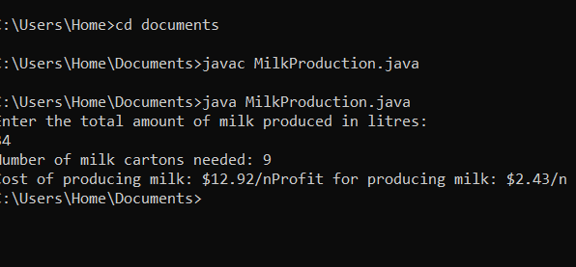

Lab Task 6
You found an exciting summer job for five weeks. It pays $15.50 per hour. Suppose that the total tax you pay on your summer job income is 14%. After paying the taxes, you spend 10% of your net income to buy new clothes and other accessories for the next school year and 1% to buy school supplies. After buying clothes and school supplies, you use 25% of the remaining money to buy savings bonds. For each dollar you spend to buy savings bonds, your parents spend $0.50 to buy additional savings bonds for you. Write a program that prompts the user to enter the pay rate for an hour and the number of hours you worked each week. The program then outputs the following: a. Your income before and after taxes from your summer job b. The money you spend on clothes and other accessories c. The money you spend on school supplies d. The money you spend to buy savings bonds e. The money your parents spend to buy additional savings bonds for you
Solution
import java.util.Scanner;
public class Job{
public static void main(String[] args){
Scanner input = new Scanner(System.in);
System.out.println("Enter the pay rate per hour: $");
double PAY_RATE_PER_HOUR = input.nextDouble();
System.out.println("Enter the number of hours worked per week: ");
int HOURS_WORKED_PER_WEEK= input.nextInt();

int WEEKS = 5;
double TAX_RATE= 0.14;
double CLOTHES_SPENDING_RATE= 0.10;
double SCHOOL_SUPPLIES_SPENDING_RATE= 0.01;
double SAVING_BOND_RATE= 0.25;
double PARENTS_CONTRIBUTION_RATE= 0.50;

double incomeBeforeTaxes = PAY_RATE_PER_HOUR * HOURS_WORKED_PER_WEEK * WEEKS;
double taxAmount = incomeBeforeTaxes * TAX_RATE;
double incomeAfterTaxes = incomeBeforeTaxes - TAX_RATE;
double moneySpentOnClothes = incomeAfterTaxes * CLOTHES_SPENDING_RATE;
double moneySpentOnSchoolSupplies = incomeAfterTaxes * SCHOOL_SUPPLIES_SPENDING_RATE;
double remainingMoney = incomeAfterTaxes - moneySpentOnClothes - moneySpentOnSchoolSupplies;
double moneySpentOnSavingBonds = remainingMoney * SAVING_BOND_RATE;
double parentsContributionRate = moneySpentOnSavingBonds * PARENTS_CONTRIBUTION_RATE;

System.out.printf("Your income before taxes: $%.2f/n", incomeBeforeTaxes);
System.out.printf("Your income after taxes : $%.2f/n", incomeAfterTaxes);
System.out.printf("Money spent on clothes: $%.2f/n", moneySpentOnClothes);
System.out.printf("Money spent on school supplies: $%.2f/n", moneySpentOnSchoolSupplies);
System.out.printf("Money spent to buy saving bonds: $%.2f/n", moneySpentOnSavingBonds);
System.out.printf("Money your parents spent on additional saving bonds: $%.2f/n", moneySpentOnSavingBonds);

input.close();
}
}
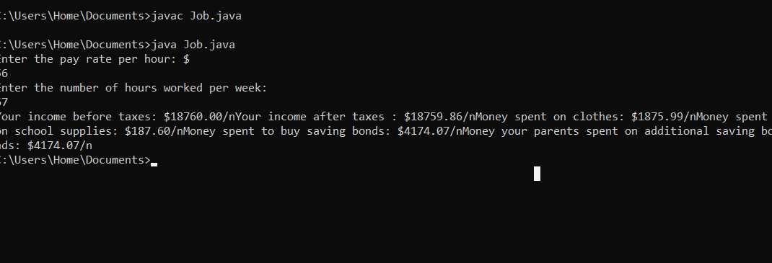
Lab Task 7
A cricket game is to be held in a stadium and there are four seating categories available for the audience. Class A seats cost $20, Class B seats cost $15, Class C seats cost $10, and Class D seats cost $5. You should write a JAVA program that asks how many tickets for each class of seats were sold and finally display the total income generated and income corresponding to ticket sales.
mport java.util.Scanner;
public class CricketTicket{
public static void main(String[] args){
Scanner input = new Scanner(System.in);
final int PRICE_A = 20;
final int PRICE_B = 15;
final int PRICE_C = 10;
final int PRICE_D = 5;
System.out.println("Enter the number of Class A tickets sold: ");
int numTicketsA = input.nextInt();
System.out.println("Enter the number of Class B tickets sold: ");
int numTicketsB = input.nextInt();
System.out.println("Enter the number of Class C tickets sold: ");
int numTicketsC = input.nextInt();
System.out.println("Enter the number of Class D tickets sold: ");
int numTicketsD = input.nextInt();
double incomeA = numTicketsA * PRICE_A;
double incomeB = numTicketsB * PRICE_B;
double incomeC = numTicketsC * PRICE_C;
double incomeD = numTicketsD * PRICE_D;
double totalIncome = incomeA + incomeB + incomeC + incomeD;
System.out.println("Income from CLASS A tickets: $" + incomeA);
System.out.println("Income from CLASS B tickets: $" + incomeB);
System.out.println("Income from CLASS C tickets: $" + incomeC);
System.out.println("Income from Class D tickets: $" + incomeD);
System.out.println("Total income generated : $" + totalIncome);

input.close();
}
}
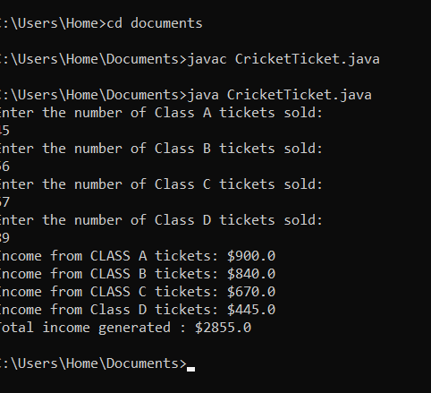
Lab Task 8
Write a program that reads an integer between 0 and 1000 and adds all the digits in the integer. For example, if an integer is 932, the sum of all its digits is 14. Enter a number between 0 and 1000: 999 The sum of the digits is 27
import java.util.Scanner;

public class MultiplicationTable8 {
public static void main(String[] args) {
Scanner sc = new Scanner(System.in);
System.out.println("Enter a number between 0 and 1000");
int number = sc.nextInt();
int hundredsDigit = number / 100;
int tensDigit = (number % 100) / 10;
int unitsDigit = number % 10;
int sumOfDigits = hundredsDigit + tensDigit + unitsDigit;

System.out.println("The sum of the digits is: " + sumOfDigits);

sc.close();
}
}
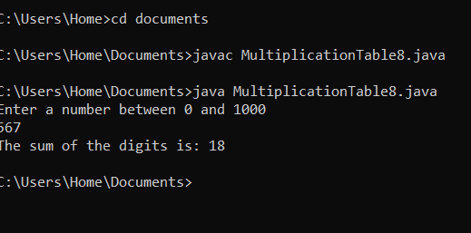

Lab Task 9
Consider the statements: double x = 75.3987; double y = 982.89764; What is the output of the following statements? System.out.printf("%.2f %n", x); System.out.printf("%.2f %n", y); System.out.printf("%.3f %n", x); System.out.printf("%.3f %n", y);
Solution
public class LabTask9{
public static void main(String[] args){
double x = 75.3987;
double y = 982.89764;
System.out.printf("%.2f %n", x);
System.out.printf("%.2f %n", y);
System.out.printf("%.3f %n", x);
System.out.printf("%.3f %n", y);
}
}
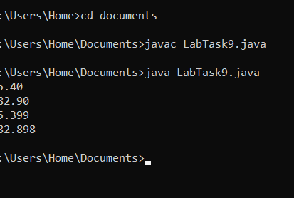
Lab Task 10
Write JAVA statements using System.out.prinf() statement to display output as given below Degrees Radians Sine Cosine 30 0.5236 0.5000 0.8660 Tangent 0.5773 60 1.0472 0.8660 0.5000 1.7320 public class DemoFormat { public static void main(String[] args) { // Display the header of the table using System.out.printf() int degrees = 30; double radians = Math.toRadians(degrees); double sin = Math.sin(radians); double cos = Math.cos(radians); double tan = Math.tan(radians); // Display the Data of the table using System.out.printf() degrees = 60; radians = Math.toRadians(degrees); sin = Math.sin(radians); cos = Math.cos(radians); tan = Math.tan(radians); // Display the Data of the table using System.out.printf()
public class DemoFormat{
public static void main(String[] args){
System.out.printf("%-10s%-10s%-10s%-10s%-10s%n", "Degrees" , "Radians", "Sine", "Cosine", "Tangent");
int degrees = 30;
double radians = Math.toRadians(degrees);
double sin = Math.sin(radians);
double cos = Math.cos(radians);
double tan = Math.tan(radians);
System.out.printf("%-10d%-10.4f%-10.4f$-10.4f%-10.4f%n",degrees, radians, sin, cos, tan);
degrees = 60;
radians = Math.toRadians(degrees);
sin = Math.sin(radians);
cos = Math.cos(radians);
tan = Math.tan(radians);
System.out.printf("%-10d%-10.4f%-10.4f%-10.4f%-10.4f%n", degrees, radians, sin, cos, tan);
}
}
